Chapter – 4
Software Simulations and Tools

4.1 MATLAB
MATLAB is a powerful computational tool widely used for modeling, simulation, and analysis in engineering and scientific applications. In the context of the proposed battery charging management system, MATLAB serves as an essential platform for simulating the integrated IoT architecture that combines solar power, Energy Storage Systems (ESS), and grid electricity. By utilizing MATLAB's robust simulation capabilities, the project aims to reduce hardware costs and facilitate modifications before actual implementation.

Fig 12 : MATLAB Tool
One of the primary advantages of using MATLAB is its ability to create detailed models of complex systems. The software allows for the simulation of various components within the battery charging management system, including the Maximum Power Point Tracking (MPPT) algorithms, charging and discharging control strategies, and real-time data monitoring processes. This capability enables researchers and engineers to analyze system performance under different scenarios without the need for physical prototypes.
MATLAB also provides a user-friendly interface for visualizing data and results, making it easier to interpret simulation outcomes. Users can generate plots and graphs to illustrate key parameters such as State of Charge (SOC), State of Health (SOH), voltage levels, and current levels over time. This visual feedback is crucial for understanding how different variables interact within the system and for optimizing control algorithms.
Furthermore, MATLAB's extensive libraries and toolboxes, such as Simulink, facilitate the development of dynamic simulations that can model real-world behavior accurately. By incorporating various environmental factors—such as temperature fluctuations and varying sunlight intensity—into the simulations, developers can ensure that the proposed system is robust and capable of adapting to changing conditions.

4.1.2 NODE- RED
Node-RED is a powerful open-source flow-based development tool designed for visual programming, particularly in the context of Internet of Things (IoT) applications. It provides a user-friendly interface that allows developers to wire together devices, APIs, and online services through a web-based flow editor. This capability makes Node-RED an ideal choice for data visualization and control in complex systems such as battery charging management.
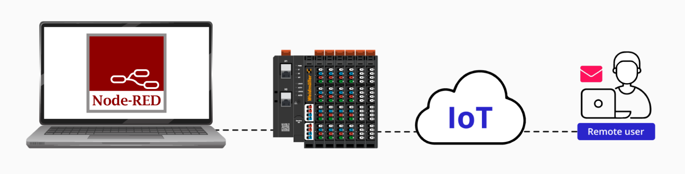
Fig 13 : Node-Red Tool
One of the primary advantages of using Node-RED is its ability to facilitate real-time data monitoring and visualization. Users can create custom dashboards that display key metrics related to battery performance, such as voltage levels, current flow, State of Charge (SOC), and temperature readings. This visual representation of data enables operators to quickly assess system performance and make informed decisions based on real-time information.
Node-RED also supports the integration of various data sources and protocols, making it versatile for diverse IoT applications. It can connect with MQTT, HTTP, WebSocket, and other communication protocols, allowing seamless interaction between different components of the battery charging management system. This flexibility is crucial for managing multiple energy sources—solar power, Energy Storage Systems (ESS), and grid electricity—ensuring that data flows efficiently between them.
In addition to visualization, Node-RED provides control capabilities that enable users to automate processes within the charging management system. For example, based on predefined conditions such as SOC thresholds or environmental factors, Node-RED can trigger actions like starting or stopping charging processes or adjusting load levels. This automation enhances operational efficiency and reduces the need for manual intervention.
The Node-RED's extensive library of pre-built nodes allows for rapid development and prototyping. Users can easily incorporate functionalities such as data logging, alert notifications, and integration with cloud services into their projects without extensive coding knowledge. This accessibility accelerates the development cycle and allows for quick iterations based on testing and feedback.
4.1.3 AWS – Amazon Web Services
Amazon Web Services (AWS) provides a comprehensive suite of cloud computing services that are instrumental in enhancing the functionality and scalability of the battery charging management system. In this project, AWS is utilized primarily for data storage, alert notifications, and visualization, leveraging services such as Amazon S3, Amazon QuickSight, and the MQTT protocol.

Fig 14 : AWS Tool

Data Storage with Amazon S3
Amazon Simple Storage Service (S3) is a highly scalable object storage service that allows for secure and durable storage of data. In the context of the battery charging management system, data collected from various sensors—such as voltage levels, current measurements, temperature readings, and State of Charge (SOC)—is stored in S3 buckets. This centralized data storage enables easy access and retrieval of historical data for analysis and reporting.

The use of S3 also ensures that data is backed up and protected against loss, providing a reliable solution for long-term data retention. The flexibility of S3 allows users to store vast amounts of data without worrying about capacity limits, making it ideal for IoT applications where data generation can be substantial.
Email Alerts
AWS provides robust notification services through Amazon Simple Notification Service (SNS), which can be integrated with the battery charging management system to send email alerts based on predefined conditions. For instance, if the SOC falls below a certain threshold or if an overcurrent condition is detected, SNS can automatically trigger an email alert to notify system operators or users. This proactive approach enhances operational awareness and allows for timely interventions to prevent potential issues.

Data Visualization with Amazon QuickSight
Amazon QuickSight is a business intelligence service that enables users to create interactive dashboards and visualizations from their data stored in S3. By integrating QuickSight into the battery charging management system, stakeholders can gain insights into system performance through visually appealing charts and graphs.
Users can build custom dashboards that display key performance indicators (KPIs), such as energy production from solar panels, charging efficiency, historical trends in SOC, and operational metrics. The ability to visualize this data in real-time aids in decision-making processes and helps identify patterns or anomalies in system behavior.
MQTT Protocol Integration
The Message Queuing Telemetry Transport (MQTT) protocol is a lightweight messaging protocol designed for low-bandwidth and high-latency networks, making it ideal for IoT applications. In this project, MQTT facilitates communication between various components of the battery charging management system and AWS services.

By using MQTT, real-time data from sensors can be transmitted efficiently to AWS for processing and storage. This protocol supports the publish-subscribe model, allowing different devices to communicate seamlessly without direct connections. This flexibility enhances the scalability of the system as new devices or sensors can be added easily without significant reconfiguration.
The combination of MATLAB for simulation, Node-RED for data visualization and control, and AWS for data storage and analytics creates a comprehensive framework for managing battery charging in electric vehicles. These tools work together to optimize operational efficiency, enhance user experience, and promote sustainable practices through effective utilization of renewable energy sources. By leveraging these technologies, the proposed IoT architecture not only addresses current challenges in EV charging infrastructure but also positions itself for future scalability and innovation in energy management solutions.

